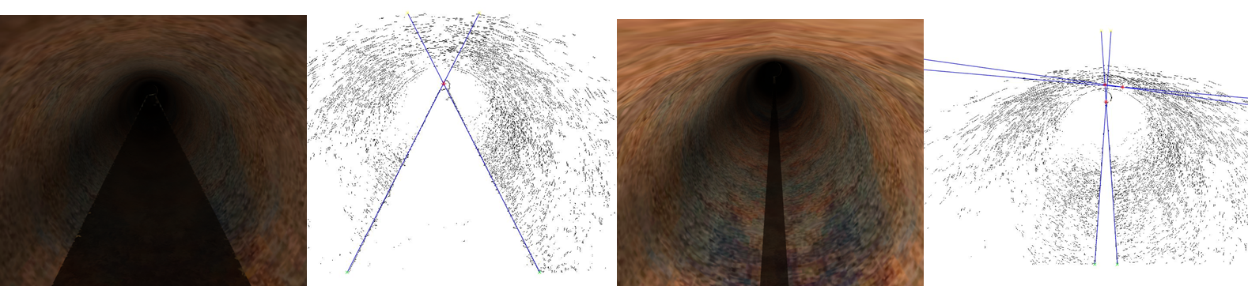**Introduction**

CE-791

**SeyedMojtaba Noghabaei**

CE-791

Vision Based Volumetric Flow Measurement for Wastewater and Storm water Networks

//Overflow detection and monitoring for wastewater networks and post-disaster response

Overflow in wastewater and storm water networks is one of the old problems of metropolitans with old networks. Especially in cities like Chicago because of old combined wastewater networks. Detection of these overflows and the reasons behind might be very helpful in post and pre disaster responses.

// Leak and crack detection

Beside overflow, one of the problems in wastewater and storm water networks is cracks. It is almost easy to find leakages and cracks in water networks because it is easy to measure the exact volumetric flow from the reservoir and total network consumptions. Furthermore sensors in water system are more advanced than sensors in wastewater and storm water networks. So these problems make it harder to detect pipe malfunctions and cracks.

//Clog detection and pipe cleaning

In addition to aforementioned problems it is hard to detect clogs especially in wastewater networks and it is hard to determine which pipes need cleaning. By knowing this, utility managers are able to reduce maintenance cost for pipe cleaning.

//IOT ideas for wastewater networks

With advancements in sensors and Internet of Things (IoT) it is possible to solve these old problems using cheap sensors and analyzing their data. Several types of sensors developed by researchers for water networks in order to reduce leakage. Besides, some sensors have valves so the operators and utility managers can simply close the valves in some parts of the network. Although there is a capability of developing such sensors for wastewater and storm water networks as well, yet these sensors are barely used in these networks.

//Vision based sensor

Low-cost vision based sensors can be one of the easiest and efficient solutions for wastewater and storm water networks. These vision based sensors give the operators the ability to watch inside of the pipes whenever they want. Besides using image processing approaches it is very easy to detect water velocity and volumetric flow rate.

**Background**

**Water system**

Volumetric flow measurement and pressure are two main factors for water network monitoring. Some sensors are able to measure pressure and volumetric flow while give the operators the power to close the analogue valves using remote commands. These kinds of sensors with relatively high computational power are more expensive than regular sensors. The key problem with these kinds of sensors is power. Usually these sensors need high voltage for their operation and it is almost impossible to power these sensors with simple batteries for long terms. But these sensors can be useful for main nodes of water networks and it is almost impossible to use them on each node or pipe. (Kartakis, Abraham, and McCann 2015)

able to measure pressure and volumetric flow while give the operators the power to close Some sensors with minimal power consumptions were applied for detecting pressure change and measuring temperature in water networks. These sensors can detect pressure changes using Force Sensitive Resistors. The power consumption in these sensors are so minimal that they have more than 100 year’s lifetime with two AA size lithium ion batteries. By application of energy harvesting methods these sensors can have an unlimited lifetime. ZigBee technology gives these devices the capability of low bandwidth and long range internet connection and mesh networks. (Sadeghioon et al. 2014)

**Water quality sensors**

Water quality sensors can play a vital role in water networks. New sensors are able to detect pb ions. These platforms are low cost and using a simple camera and UV light give the operators the ability to monitor water quality in different parts of a water network. (Sun et al. 2018)

**Storm water vision-based systems**

Vision based sensors might be a great way to measure water level in storm water networks. The main problems with these kinds of sensors is lack of light. But if sensor uses proper pieces of equipment it can be cheap and very efficient. These sensors can simply detect water level so operators can make proper decision in case of an overflow(Nguyen et al. 2009)

**The Proposed System: Vision Based Volumetric Flow Measurement for wastewater and Storm water Networks**

**System Operation Summary**

A camera is mounted on a raspberry pi zero w which receives the image and video content from the camera, analyzes and uploads the stream on a server through a ZigBee or Wi-Fi mesh network connection. This stream and the results from the analysis are downloaded by the user from anywhere which is needed and viewed in VR headset to achieve high immersion and better collaboration.

//The calculation of level of water will be automatically provided by analyzing images using different computer vision approaches.

This system consists of four different components for the sensor itself. The components are main board which can be raspberry pi zero w, camera, ZigBee module, and batteries. Figure 1 below shows the different components of the sensor.

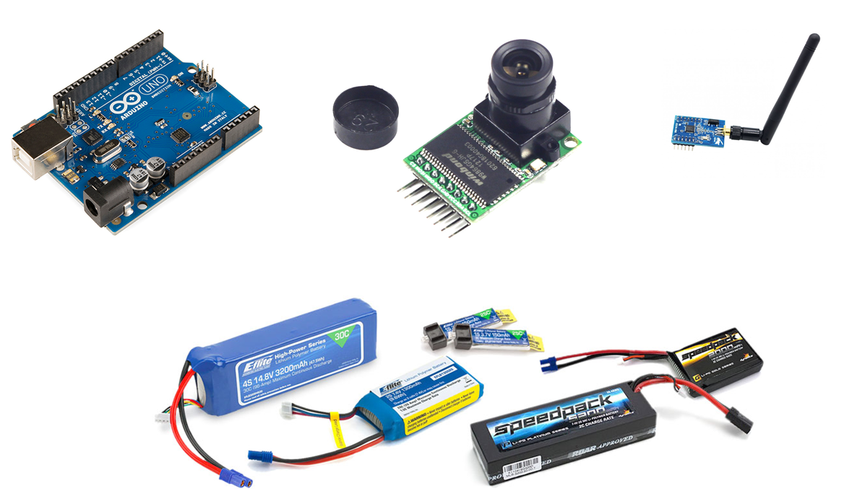

**Figure 1: Different vision based sensor parts**

**System architecture**

The System consists of 3 different layers which include client layer, server layer, and sensor layer. The system needs to transmit two types of data- the visual data for inspection and the hydraulic variables data achieved by image processing in the main board. Figure 2 below shows the architecture of the system.

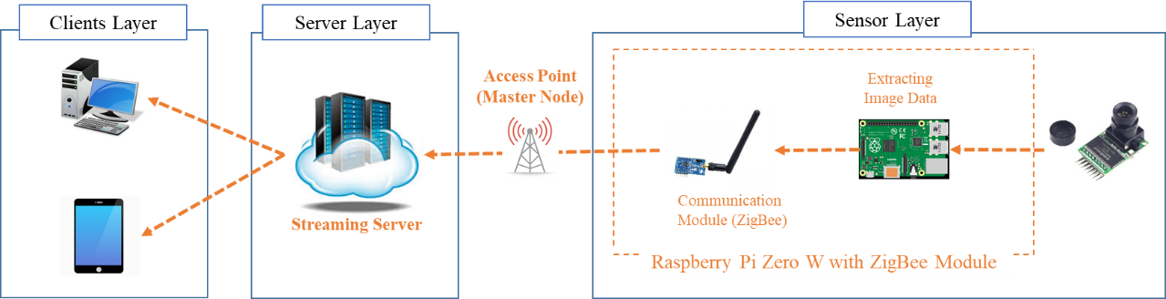

**Figure 2: System Architecture Details**

The system uses peer to peer network connections and by using this type of networks it is possible to increase the range and reliability of the network. This type of network has a major deficiency in bandwidth. For the sensor introduced in the current research it is not necessary to have high bandwidth. Figure 3 below shows the architecture of the system network.

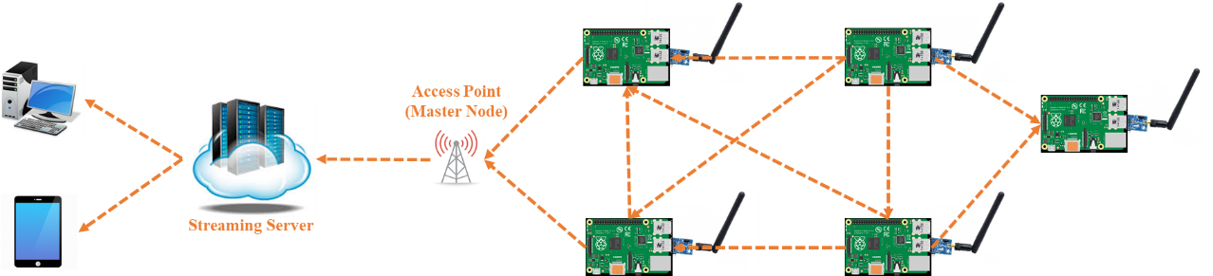

**Figure 3: System Architecture System and Network Details**

This sensor consists of three different layers as showed in the Figure 2.

The ***Client Layer*** includes the components at the user location. A typical mobile device or personal computer which has a connection to the server. The computer runs an application designed to connect to server.

The ***Server Layer*** consists of a dedicated cloud-based server that can perform two tasks. 1) Transmits the data obtained from the sensors to the client, and 2) performs real-time analysis on the data and alert clients whenever is needed.

The **Sensor *Layer*** consists of a small computer system (Raspberry Pi Zero W) equipped with ZigBee connection and a camera. Depending on the type of the computer system it is possible to either analyze the images in each node or do the analysis on the server.

By analyzing the image data from the sensors, it is possible to measure different hydraulic variables such as water velocity, volumetric flow rate, and water level in the pipe.

It is possible to measure the water level in the pipe by measuring the slope of vanishing lines and vanishing lines are the perspective lines that can be detected using edge detection filters in image processing. Figure 4 below shows the vanishing lines and how the slope of those lines relates to the water level.

Using a linear regression it is possible to relate the slope of vanishing lines to the water level and by knowing the water level, diameter of the pipe, and the slope of the pipe, it is possible to measure all main hydraulic variables of the flow in the pipe.

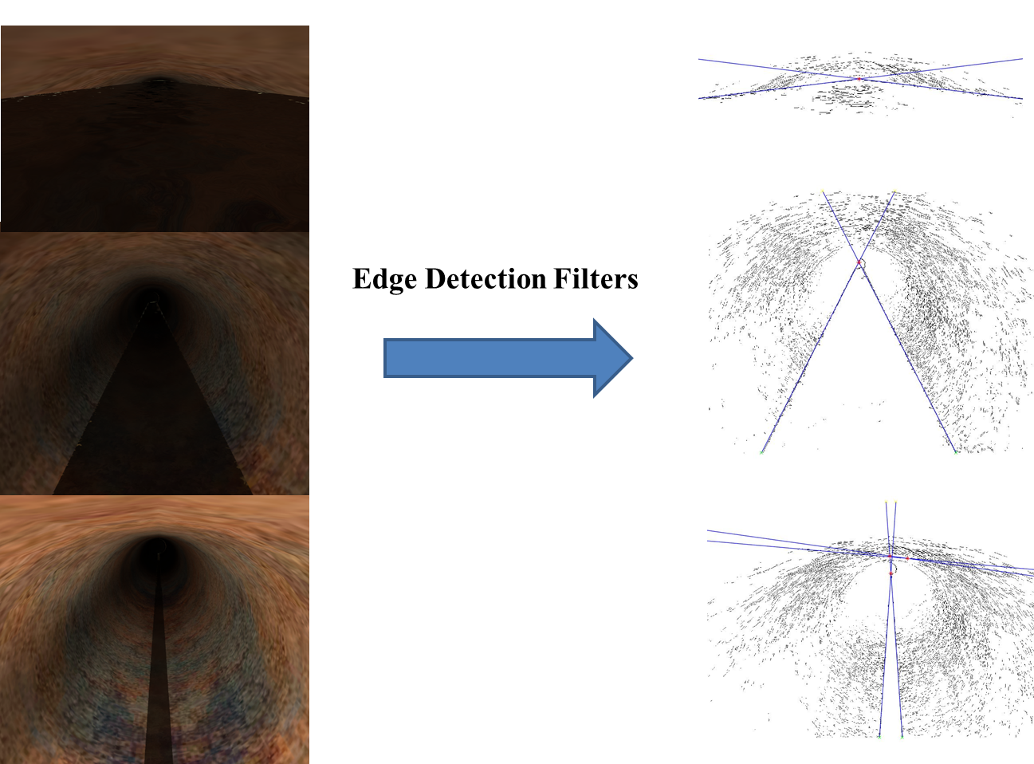

**Figure 4: vanishing lines detection using edge detection approach**

**System Test & Demo**

It is possible to make the sensor and test it in the simulated environment in the hydraulic lab, but this is an optional task.

**System Application**

This smart network of sensors are able to help the utility managers in several way as follows:

1. **Real-time Wastewater Network Monitoring**

The proposed system is able to monitor wastewater and storm water network in real time. This capability gives the utility managers and technicians to solve the problems of the network within days and reduce overall maintenance costs. Furthermore, this can reduce future maintenance costs because these prompt repairs prevents the future problems of the network. Figure 5 below shows a sample of proposed approach in a similar network.

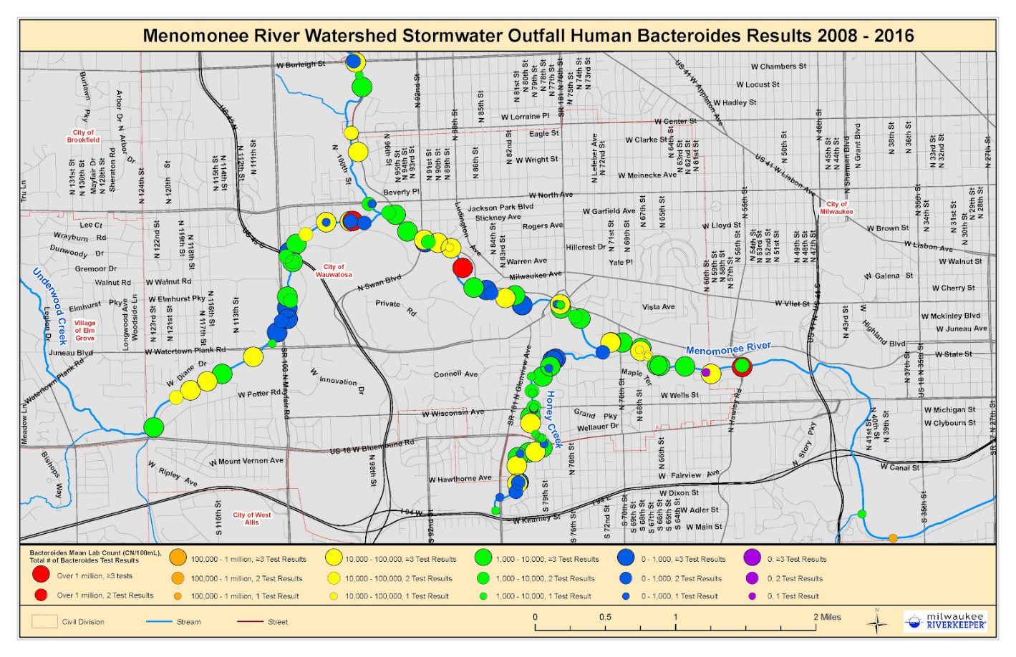

**Figure 5: Storm water outfall human bacteroides results**

1. **Water Flow Mapping**

One of the important things that utility managers want to know during the disaster or rain fall is the real time analysis of the network so they can understand which pipe is going to face an overflow. Using this system it is possible analyze upstream of the pipes so we can predict which pipe is going to face an overflow so utility managers can send an alert to the citizens who lives in that vicinity. This alert can save citizens property and also provide enough time for utility managers and technicians to solve the problem beforehand. Figure 6 and 7 below show the sample of flood analysis in an urban are and the lag time between rainfall peak and discharge peak of the storm water network.

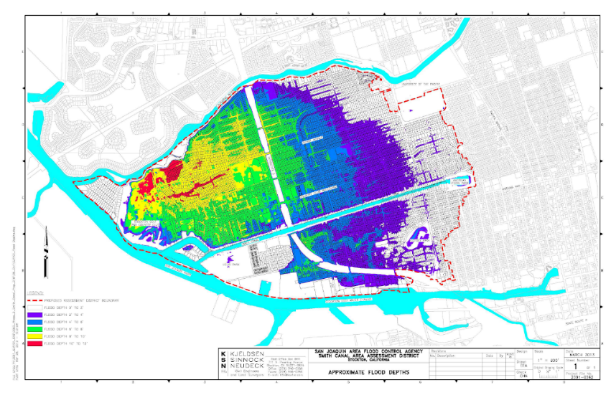

**Figure 6: flood analysis in an urban area**

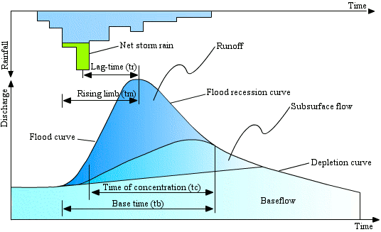

**Figure 7: lag time between rainfall peak and discharge peak of the storm water network**

1. **Immersive Virtual Environment for better management and communication**

Using this system, it is possible to utilize new technologies like Virtual Reality (VR), Augmented Reality (AR), and Mixed Reality (MR). This system can improve the collaboration between utility managers and technicians and let them try different scenarios during a flood or excessive rainfall.

Also utility managers can simply watch inside every pipe whenever they want or change some parts of the network so they can have better understanding of the storm water network.Figure 5 below shows a sample of proposed approach in a similar network

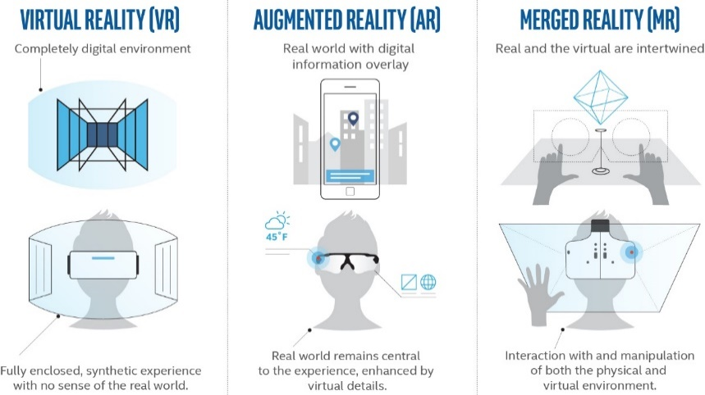

**Figure 8: vanishing lines detection using edge detection approach**

**Timeline**

The proposal consists of several task and three optional task and due for finishing the proposal is the end of April. Table 1 below shows the proposed timeline.

**Table 1: Timeline**

|  |  |  |  |
| --- | --- | --- | --- |
| Task Name | Duration | Start | Finish |
| Testing Real Camera (Optional) | 14 days | Wed 2/21/18 | Mon 3/12/18 |
| Model the Network (Base Model) | 14 days | Wed 2/21/18 | Mon 3/12/18 |
| Auto Scheduling Tables(Optional) | 3 days | Tue 3/13/18 | Thu 3/15/18 |
| Developing Optimization and GA(Optional) | 14 days | Fri 3/16/18 | Wed 4/4/18 |
| Model the Network (Detailed Model) | 4 days | Thu 4/5/18 | Tue 4/10/18 |
| Flow Simulation | 10 days | Tue 3/13/18 | Mon 3/26/18 |
| Auto Alert System | 5 days | Tue 3/27/18 | Mon 4/2/18 |
| Virtual Reality | 7 days | Wed 4/11/18 | Thu 4/19/18 |
| Mixed Reality (Optional) | 3 days | Fri 4/20/18 | Tue 4/24/18 |

**Limitation / Future Works**

* Low bandwidth with ZigBee
* Limited battery lifetime (Energy harvesting using propellers)
* Low computational power
* Add water quality sensors
* Water jets inside the pipes
* Robotic Arms in order to Correct Small Issues
* Measuring particle diameter inside pipes

**Conclusion**

**References**

Kartakis, S., E. Abraham, and J. A. McCann. 2015. “WaterBox: A Testbed for Monitoring and Controlling Smart Water Networks.” *1st ACM Int. Workshop on Cyber-Physical Systems for Smart Water Networks (CySWater)*, no. April 2015:1–6. https://doi.org/10.1145/2738935.2738939.

Nguyen, L. S., B. Schaeli, D. Sage, S. Kayal, D. Jeanbourquin, D. A. Barry, and L. Rossi. 2009. “Vision-Based System for the Control and Measurement of Wastewater Flow Rate in Sewer Systems.” *Water Science and Technology* 60 (9):2281–89. https://doi.org/10.2166/wst.2009.659.

Sadeghioon, Ali, Nicole Metje, David Chapman, and Carl Anthony. 2014. “SmartPipes: Smart Wireless Sensor Networks for Leak Detection in Water Pipelines.” *Journal of Sensor and Actuator Networks* 3 (1):64–78. https://doi.org/10.3390/jsan3010064.

Sun, Han, Wanbo Li, Zhen Zhen Dong, Chong Hu, Chung Hang Leung, Dik Lung Ma, and Kangning Ren. 2018. “A Suspending-Droplet Mode Paper-Based Microfluidic Platform for Low-Cost, Rapid, and Convenient Detection of lead(II) Ions in Liquid Solution.” *Biosensors and Bioelectronics* 99 (August 2017). Elsevier B.V.:361–67. https://doi.org/10.1016/j.bios.2017.07.073.